**1. INTRODUCTION**

1.1 0verview:

Startup analysis helps us to find the important steps to be taken to run the business successfully and helps to understand how many numbers of startups where introduced year by year. And also it gives information about which state is leading in starting more number of companies. A startup analysis is essential to the success of any startup business. It allows intrepreneurs to identify the key areas that need improvement and make necessary changes early on. Doing a startup analysis also allows startups to track their progress and ensure that they are on track to achieve their goals.

**1.2 Purpose:**

The primary objective of a firm venture startup is to grow the new venture and make it a sustainable, profitable, business. Every venture-backed startup needs to have an eye on long-term growth, but the most successful startups have a plan for how they will achieve that growth. By this analysis we can overcome our disadvantages and by comparing our development on year by year in bar graph we can plan our moves.

**2 Problem Definition & Design Thinking**

**2.1 Empathy Map**

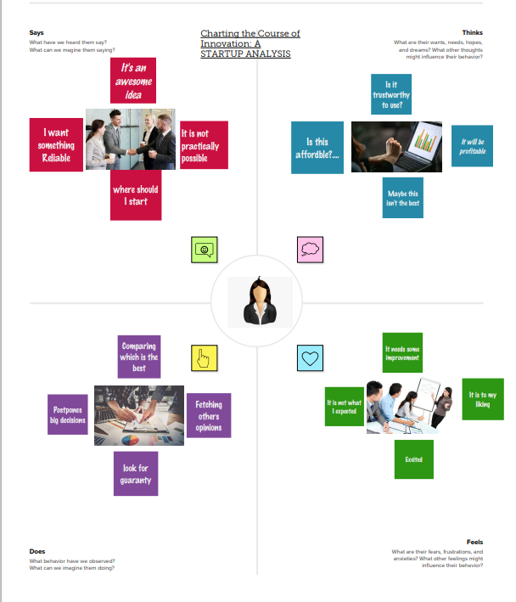

**2.2 Ideation & Brainstorming Map:**

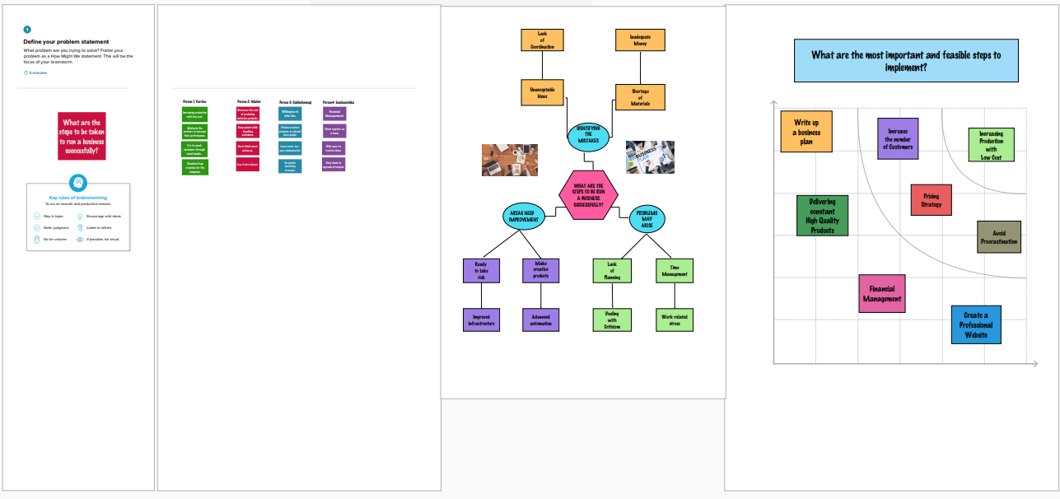

**3. RESULT**

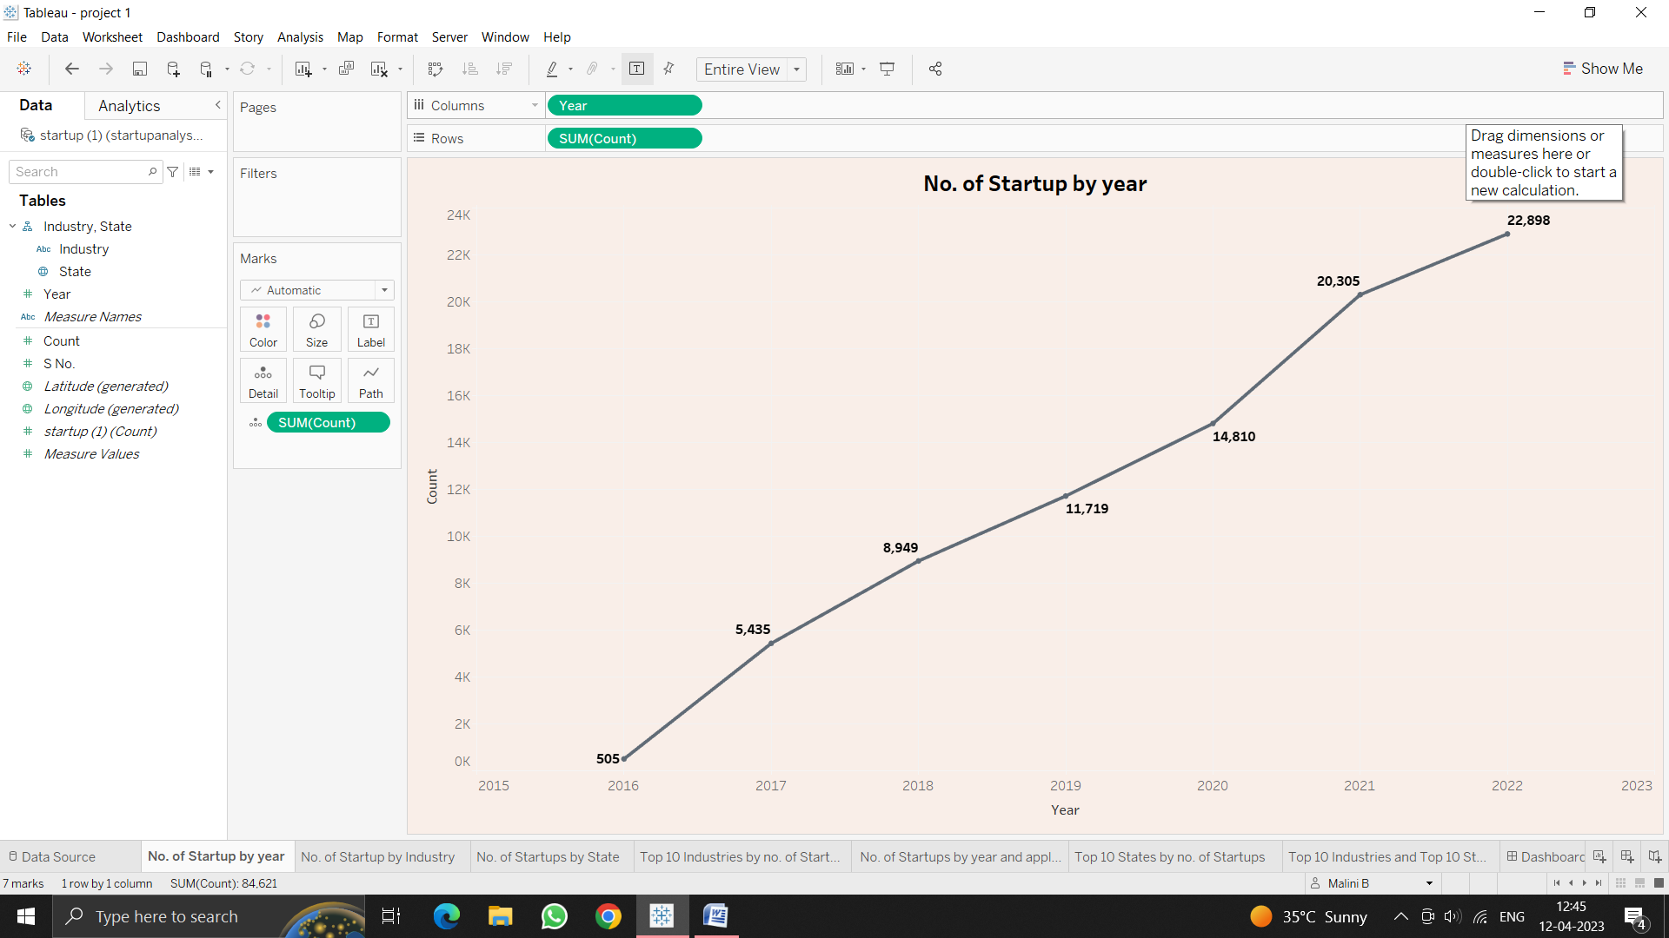

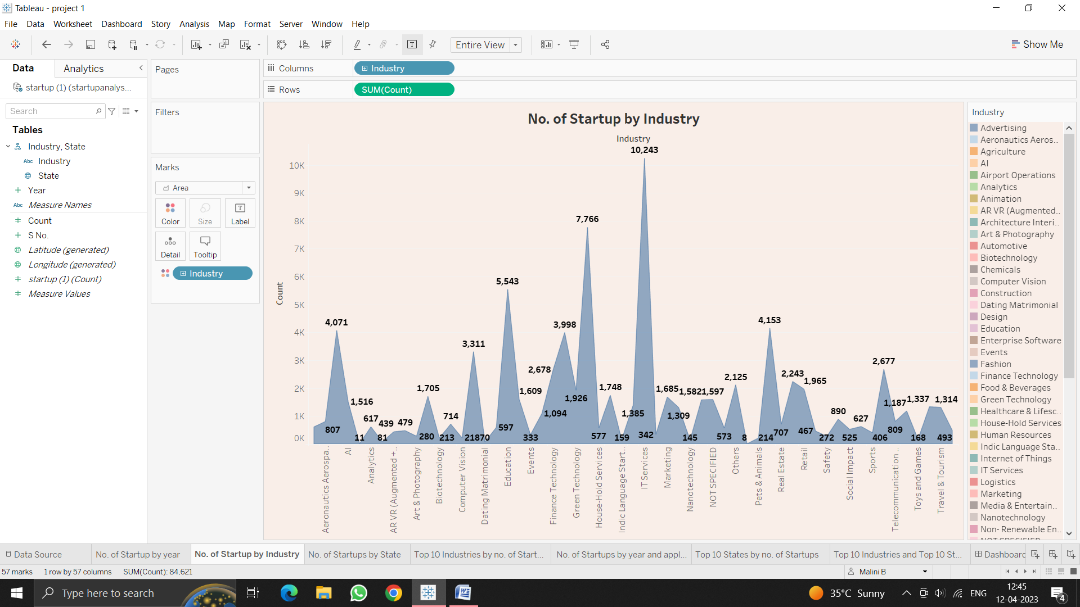

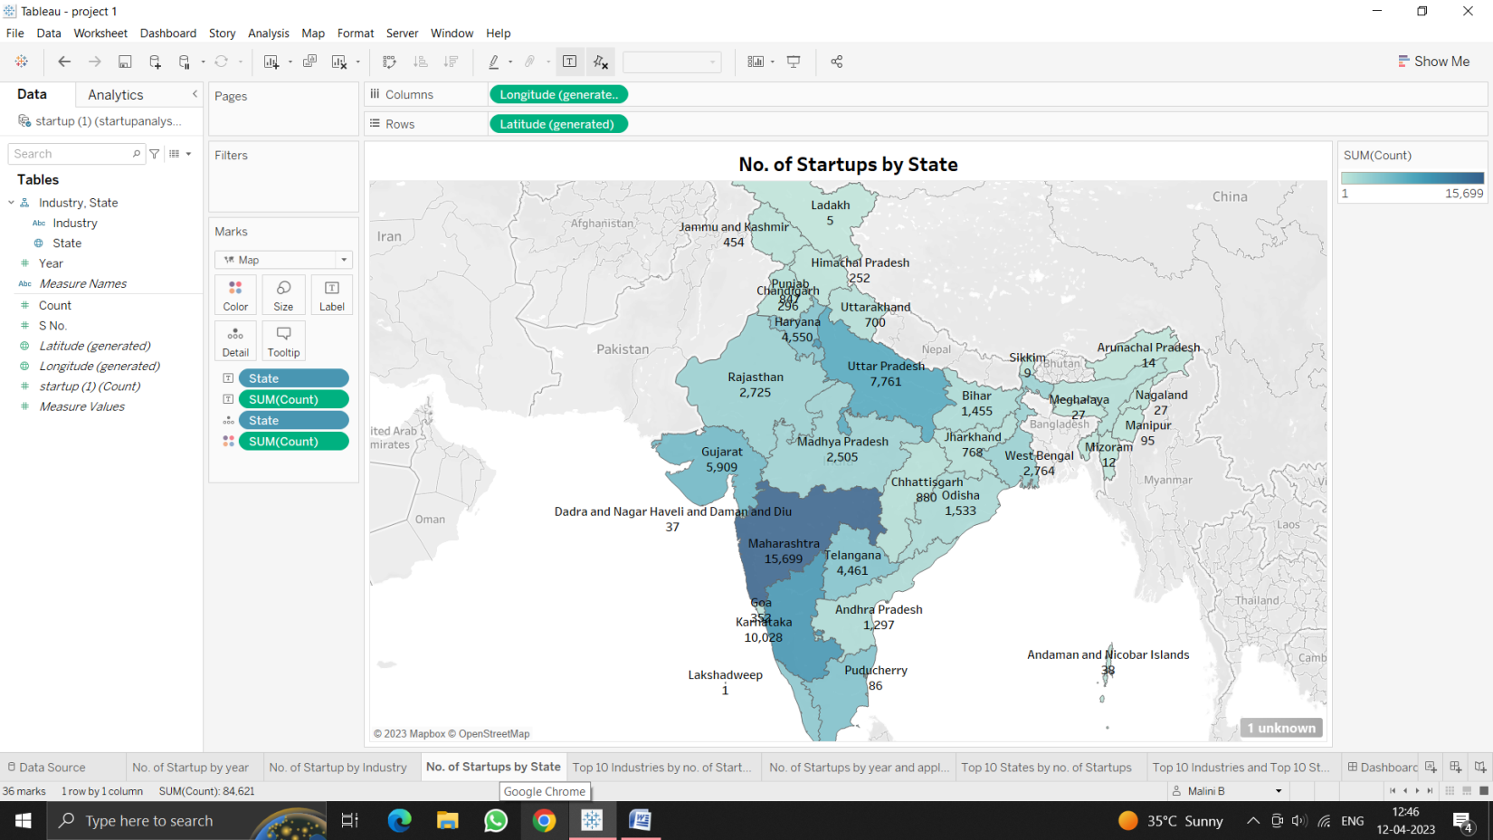

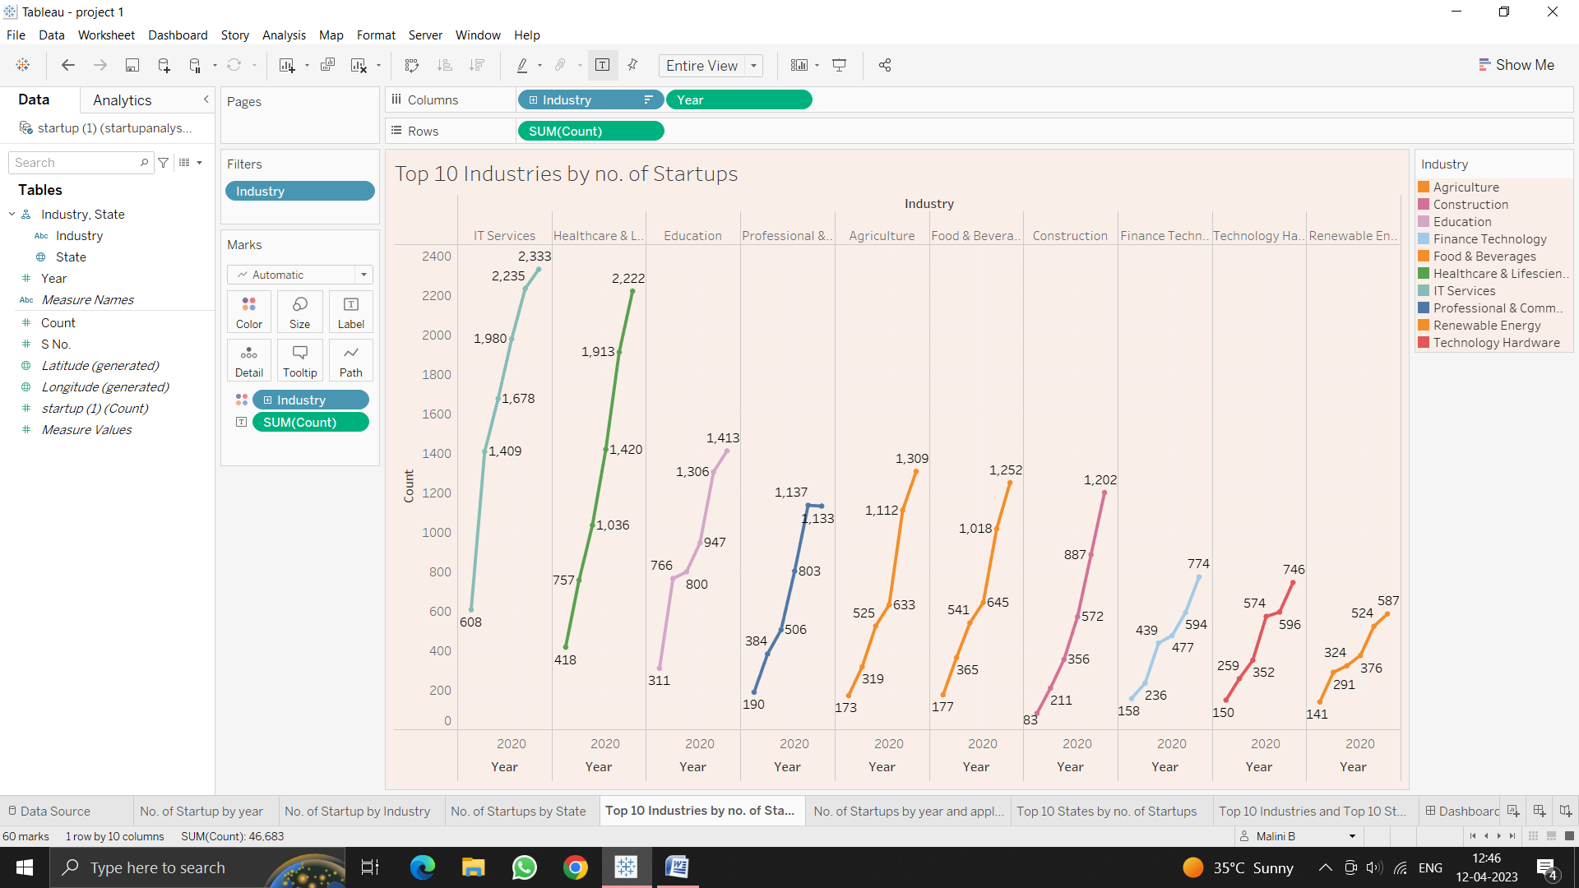

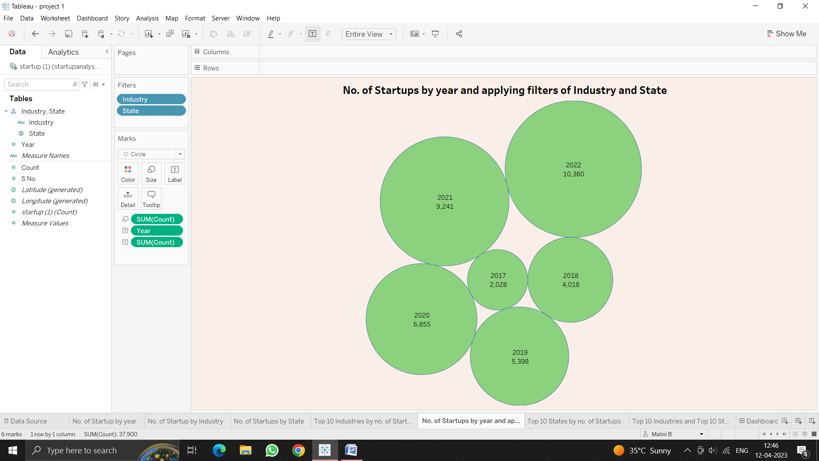

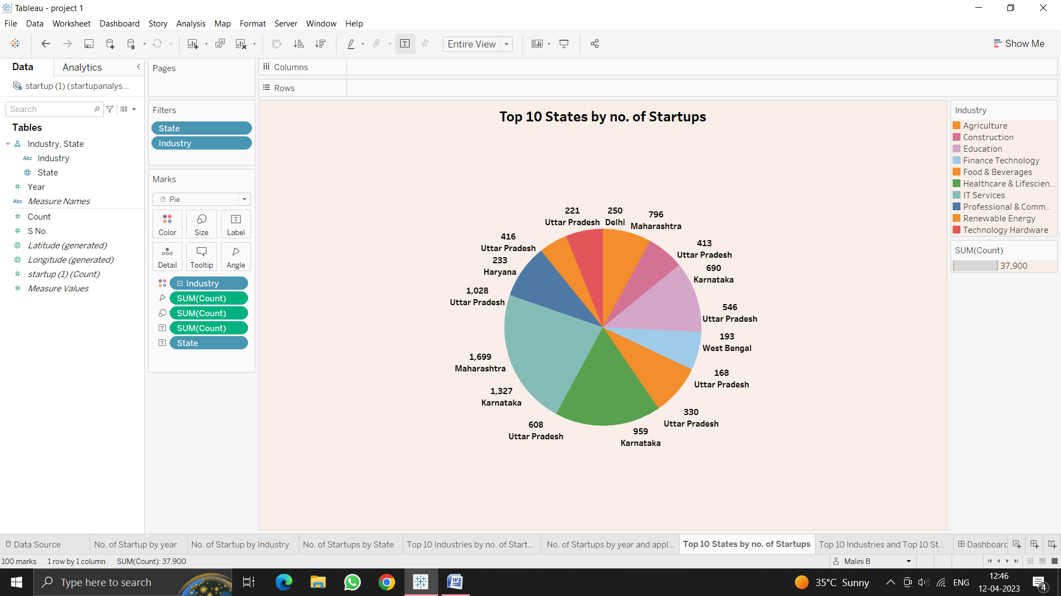

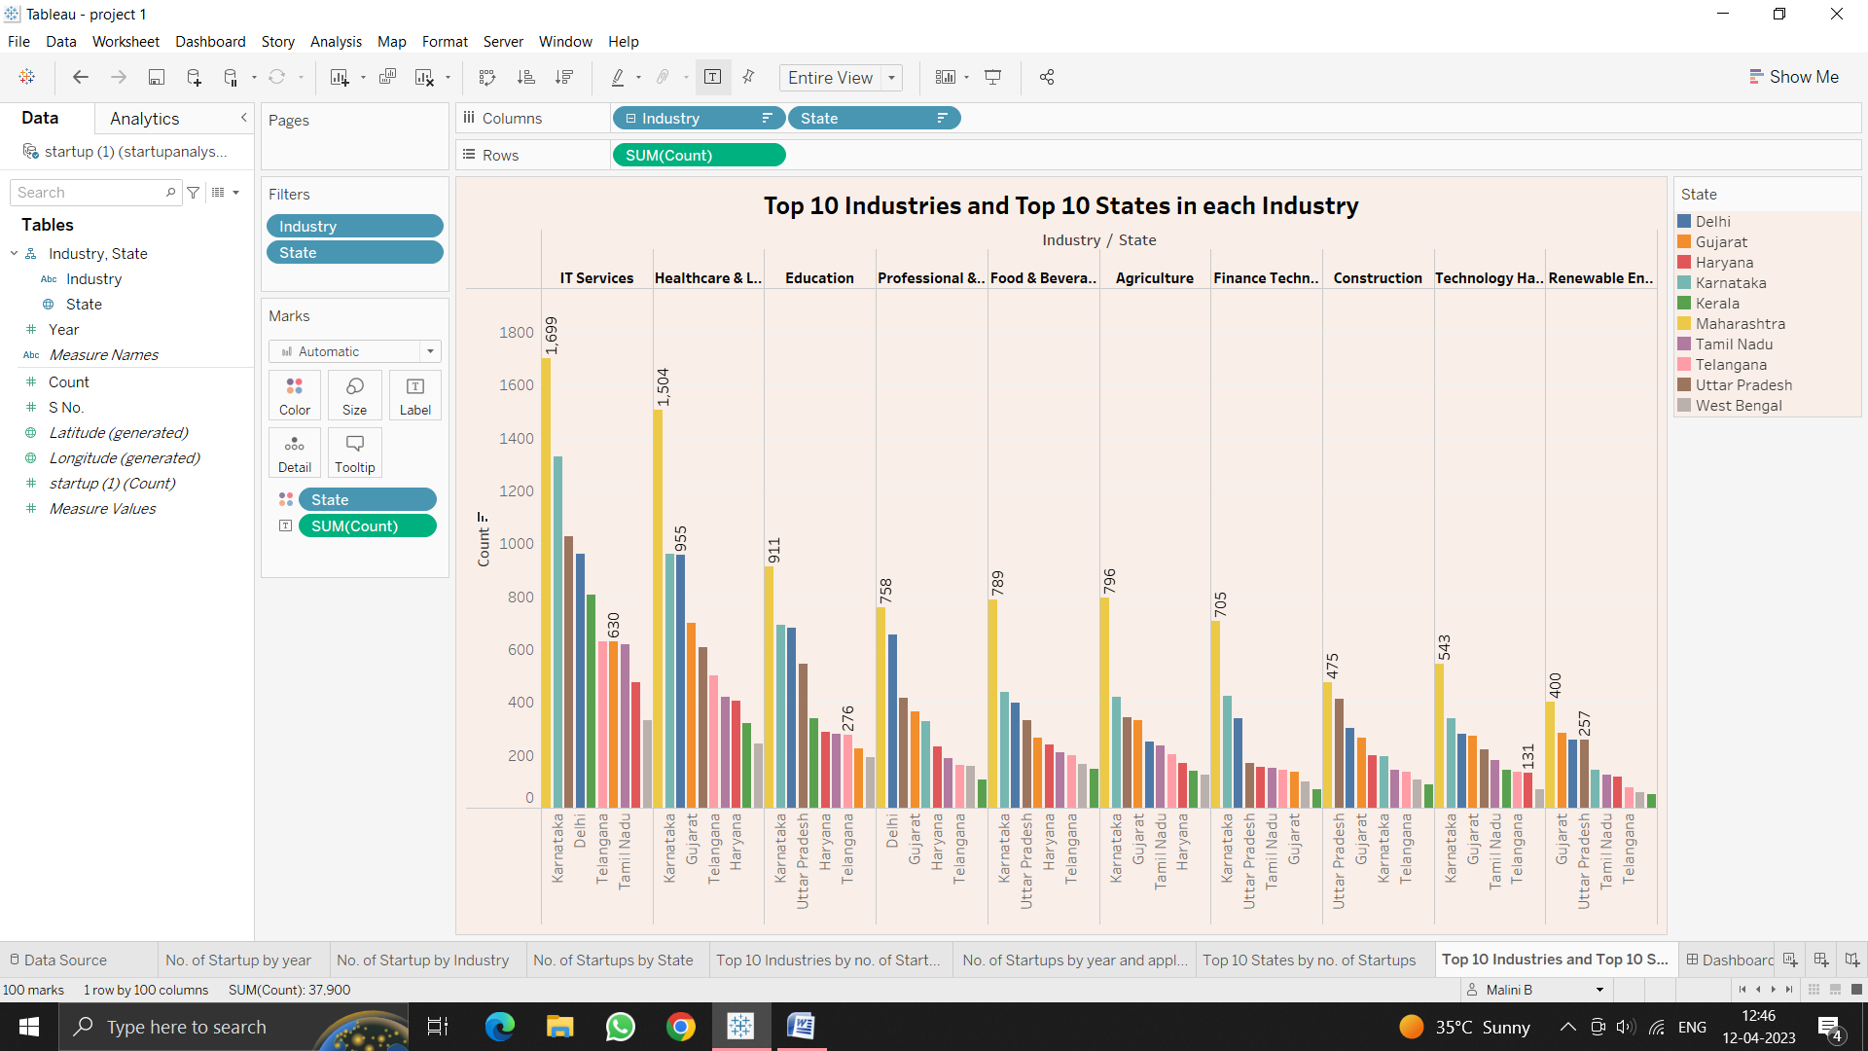

**4. ADVANTAGES & DISADVANTAGES**

**Advantages:**

* Startup analysis helps us to know how to lead our company into a profitable one.
* By this we can plan our moves.
* Improve our business strategies.
* Getting to know your business well.
* Weighting your competitor’s strength.

Disadvantages**:**

* Lot of time consuming on this progress.
* Greater personal responsibility.
* Potential financial risks.
* More personal stress.
* Requires a professional network.

5**. APPLICATIONS:**

The financial world is a volatile place, and business analytics helps to extract insides that help organizations maneuver their way through tricky terrain. Corporations turn to business analytics to optimize budgeting, banking, financial planning, forecasting and portfolio management.

6. **CONCLUSION:**

By embarking on a startup journey, the entrepreneur will learn a great deal about discovering actual problems, innovating solutions, analyzing markets and building the organization an processes to support these activities. This helps the entrepreneur develop an entrepreneurial mindset, through which they can also contribute to other life activities, even if they later end up working in a more traditional organization.

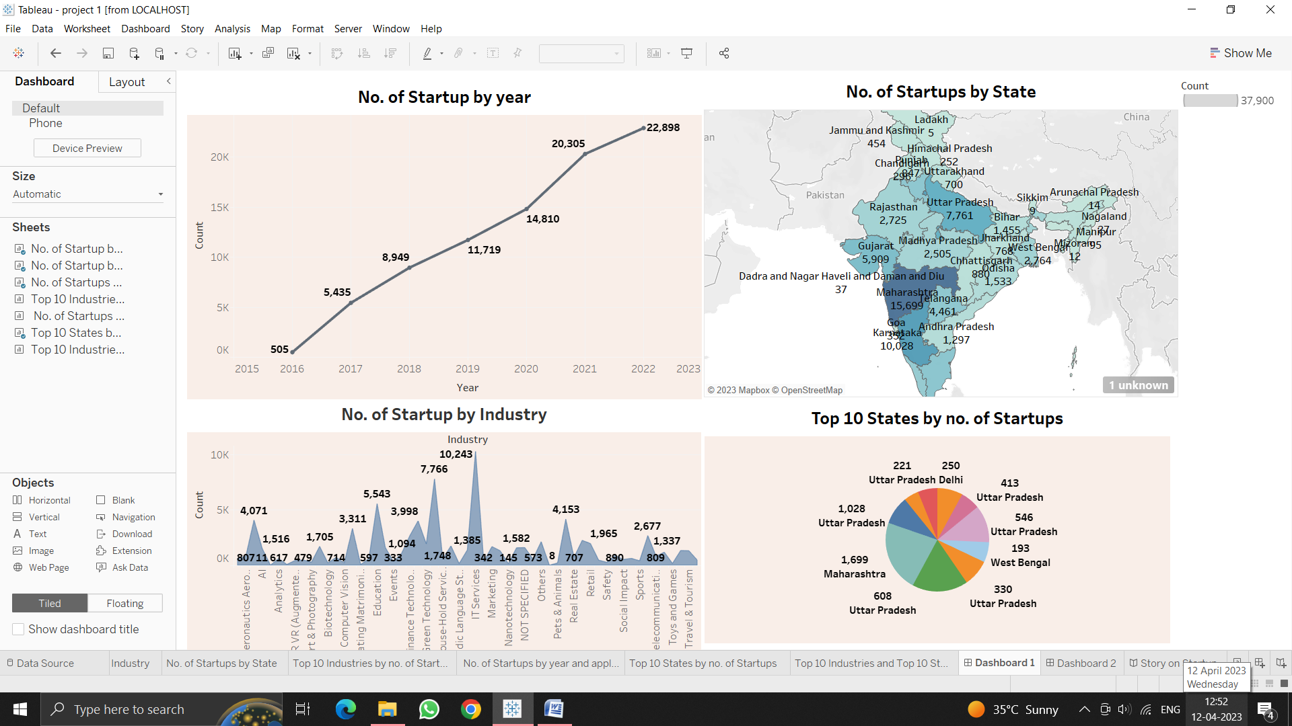

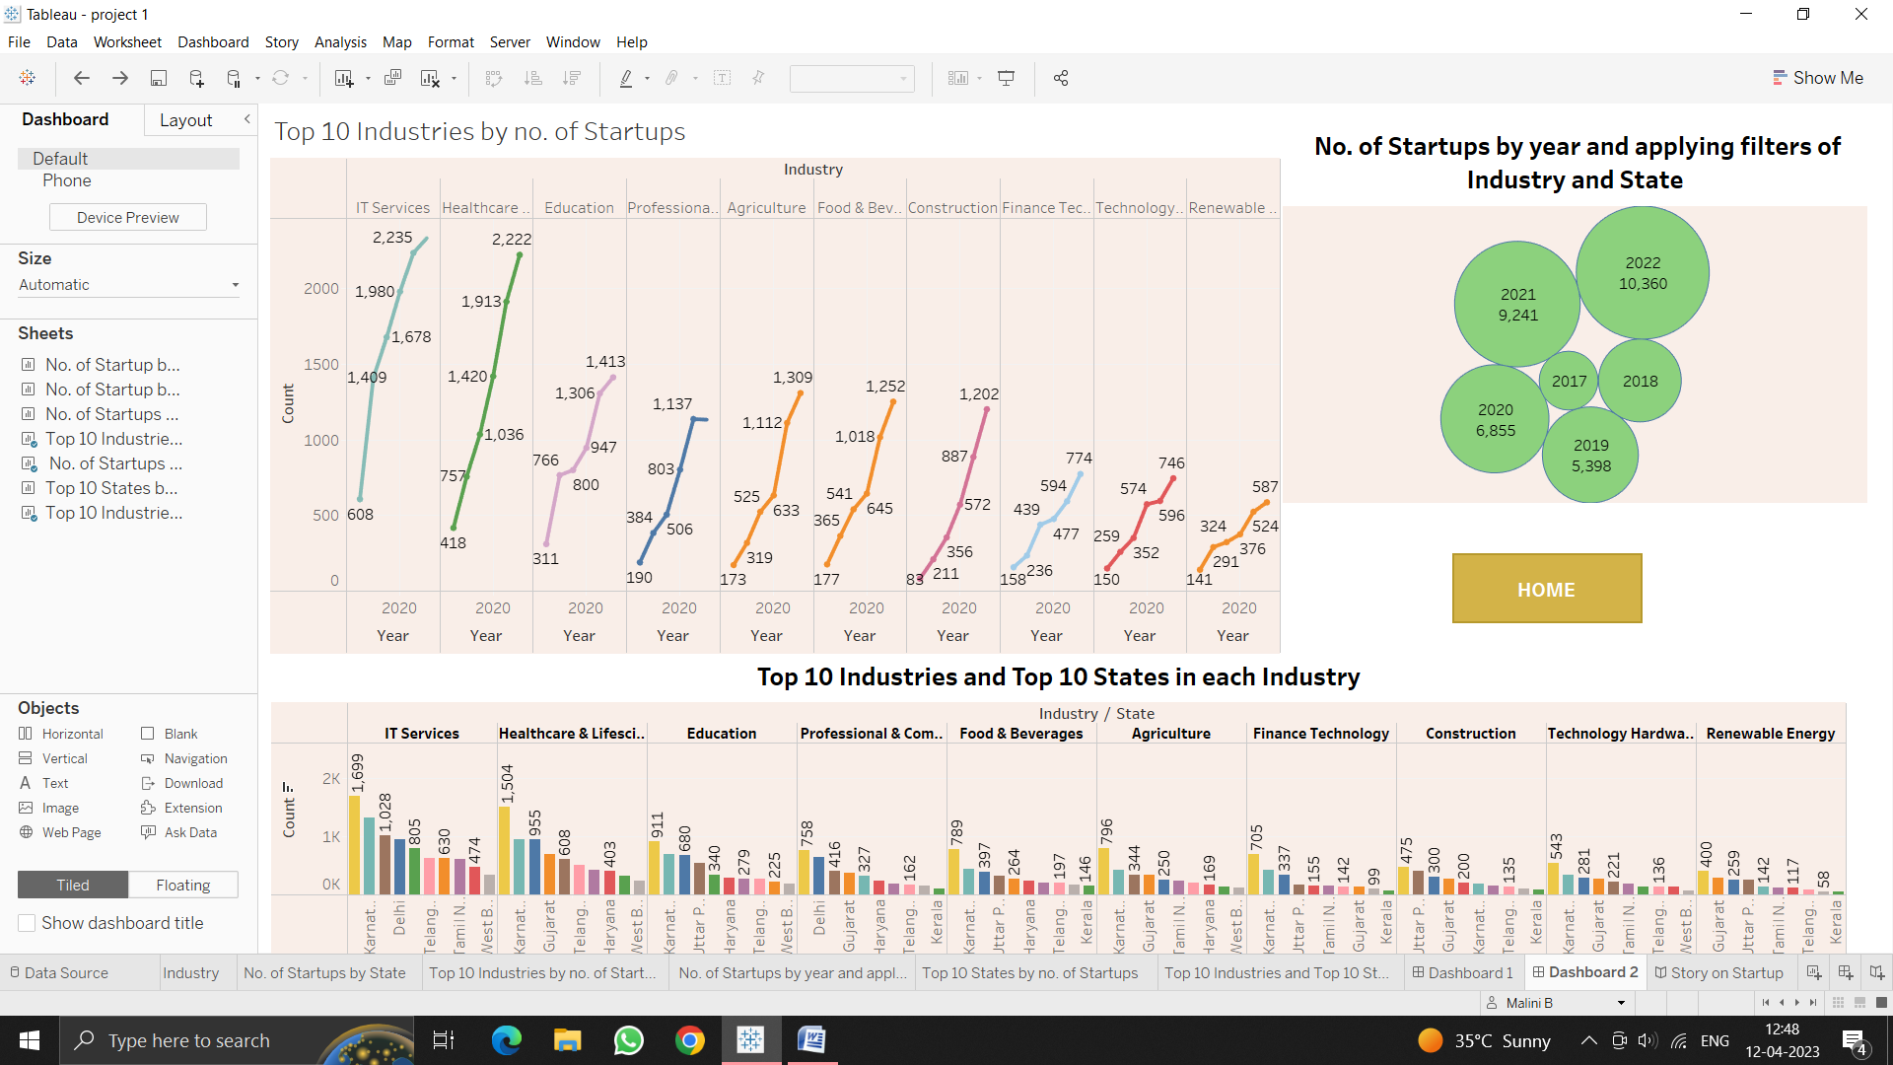

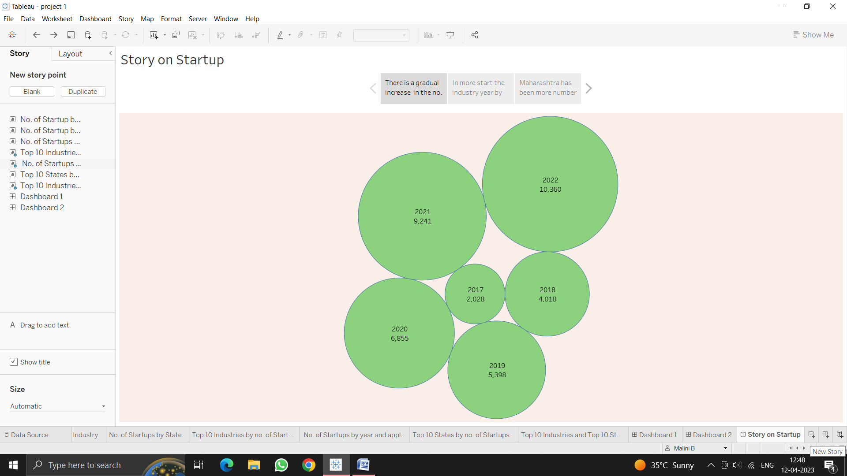

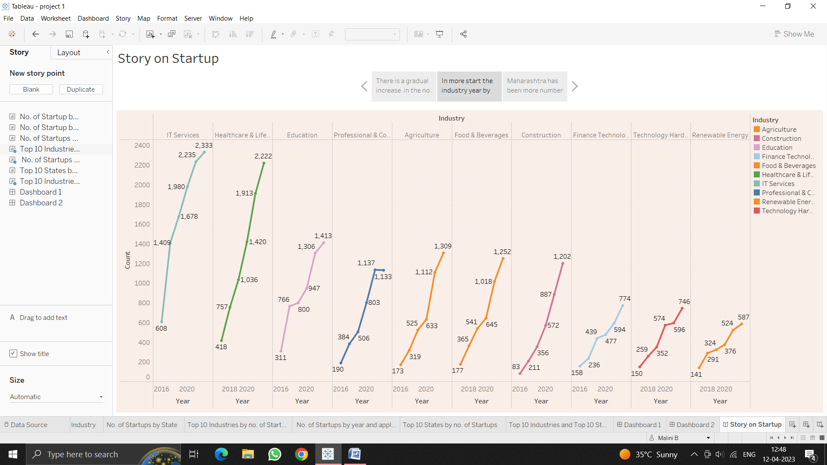

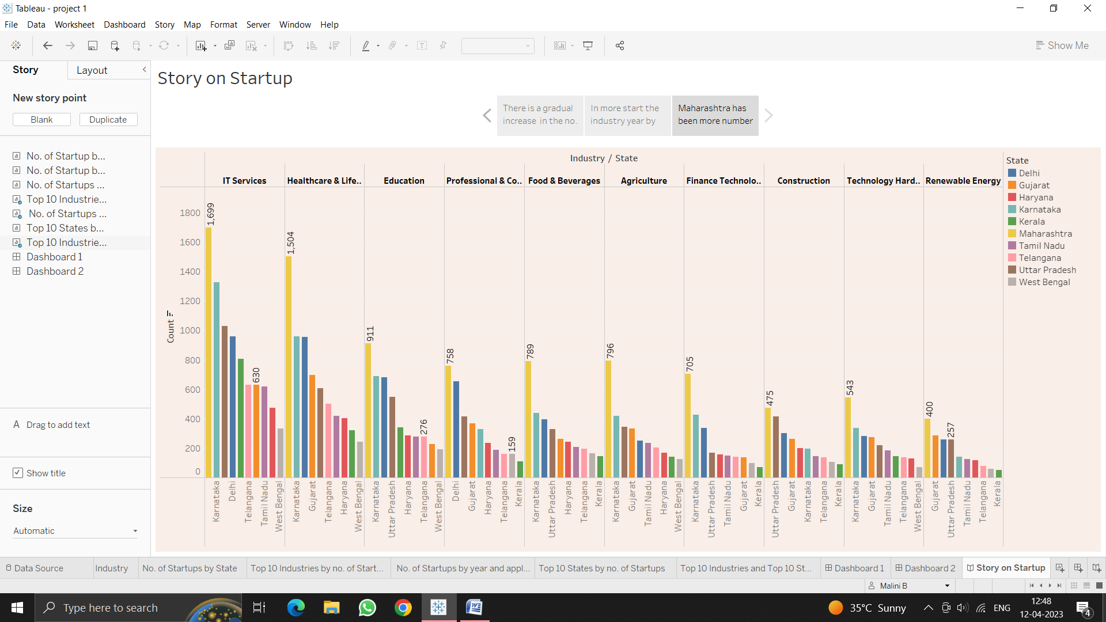

**7. FUTURE SCOPE:**

**T**he startup industry is an ever-evolving space and the future of startups looks setto be an exciting one. We currently in the midst of a digital revolution that is transforming the way businesses operate and this trend is only likely to continue. As technology advances, so too will the opportunities available to startups, and the industry will continue to change and develop to meet the demands of this new era.

**8.APPENDIX:**

index.html

<!DOCTYPE html>

<html lang="en">

  <head>

    <meta charset="utf-8" />

    <title>StartUp</title>

    <!-- mobile responsive meta -->

    <meta name="viewport" content="width=device-width, initial-scale=1" />

    <meta

      name="viewport"

      content="width=device-width, initial-scale=1, maximum-scale=1"

    />

    <!-- theme meta -->

    <meta name="theme-name" content="dtox" />

    <!-- ** Plugins Needed for the Project ** -->

    <!-- Bootstrap -->

    <link rel="stylesheet" href="plugins/bootstrap/bootstrap.min.css" />

    <!-- themefy-icon -->

    <link rel="stylesheet" href="plugins/themify-icons/themify-icons.css" />

    <!-- slick slider -->

    <link rel="stylesheet" href="plugins/slick/slick.css" />

    <!-- venobox popup -->

    <link rel="stylesheet" href="plugins/Venobox/venobox.css" />

    <!-- aos -->

    <link rel="stylesheet" href="plugins/aos/aos.css" />

    <!-- Main Stylesheet -->

    <link href="css/style.css" rel="stylesheet" />

    <!--Favicon-->

    <link rel="shortcut icon" href="images/favicon.ico" type="image/x-icon" />

    <link rel="icon" href="images/favicon.ico" type="image/x-icon" />

  </head>

  <body>

    <!-- navigation -->

    <section class="fixed-top navigation">

      <div class="container">

        <nav class="navbar navbar-expand-lg navbar-light">

          <a class="navbar-brand" href="index.html"

            ><img src="images/logo1.png" alt="logo" width="70" height="70"

          /></a>

          <button

            class="navbar-toggler border-0"

            type="button"

            data-toggle="collapse"

            data-target="#navbar"

            aria-controls="navbar"

            aria-expanded="false"

            aria-label="Toggle navigation"

          >

            <span class="navbar-toggler-icon"></span>

          </button>

          <!-- navbar -->

          <div class="collapse navbar-collapse text-center" id="navbar">

            <ul class="navbar-nav ml-auto">

              <li class="nav-item">

                <a class="nav-link" href="index.html">Home</a>

              </li>

              <li class="nav-item">

                <a class="nav-link" href="about.html">About</a>

              </li>

              <!-- <li class="nav-item">

                <a class="nav-link page-scroll" href="#feature">Feature</a>

              </li>               -->

              <li class="nav-item">

                <a class="nav-link" href="dashboard.html">Dashboard</a>

              </li>

              <li class="nav-item">

                <a class="nav-link page-scroll" href="story.html">Story</a>

              </li>

              <li class="nav-item">

                <a class="nav-link" href="contact.html">Contact</a>

              </li>

            </ul>

            <!-- <a href="#" class="btn btn-primary ml-lg-3 primary-shadow"

              >Try Free</a

            > -->

          </div>

        </nav>

      </div>

    </section>

    <!-- /navigation -->

    <!-- hero area -->

    <section

      class="hero-section hero"

      data-background=""

      style="background-image: url(images/hero-area/banner-bg.png)"

    >

      <div class="container">

        <div class="row">

          <div class="col-lg-12 text-center zindex-1">

            <h1 class="mb-3">

              Indian StartUp <br>

              Analysis and Visualization

            </h1>

            <p class="mb-4">

             We have anyalized and about the startups that are especially in India and approved by Indian Govt.

            </p>

            <a href="about.html" class="btn btn-secondary btn-lg">explore us</a>

            <!-- banner image -->

            <!-- <img

              class="img-fluid w-100 banner-image"

              src="images/hero-area/banner-img.png"

              alt="banner-img"

            /> -->

          </div>

        </div>

      </div>

      <!-- background shapes -->

      <div id="scene">

        <img

          class="img-fluid hero-bg-1 up-down-animation"

          src="images/background-shape/feature-bg-2.png"

          alt=""

        />

        <img

          class="img-fluid hero-bg-2 left-right-animation"

          src="images/background-shape/seo-ball-1.png"

          alt=""

        />

        <img

          class="img-fluid hero-bg-3 left-right-animation"

          src="images/background-shape/seo-half-cycle.png"

          alt=""

        />

        <img

          class="img-fluid hero-bg-4 up-down-animation"

          src="images/background-shape/green-dot.png"

          alt=""

        />

        <img

          class="img-fluid hero-bg-5 left-right-animation"

          src="images/background-shape/blue-half-cycle.png"

          alt=""

        />

        <img

          class="img-fluid hero-bg-6 up-down-animation"

          src="images/background-shape/seo-ball-1.png"

          alt=""

        />

        <img

          class="img-fluid hero-bg-7 left-right-animation"

          src="images/background-shape/yellow-triangle.png"

          alt=""

        />

        <img

          class="img-flui            </h1>

            <p class="mb-4">

             We have anyalized and about the startups that are especially in India and approved by Indian Govt.

            </p>

            <a href="about.html" class="btn btn-secondary btn-lg">explore us</a>

            <!-- banner image -->

            <!-- <img

              class="img-fluid w-100 banner-image"

              src="images/hero-area/banner-img.png"

              alt="banner-img"

            /> -->

          </div>

        </div>

      </div>

      <!-- background shapes -->

      <div id="scene">

        <img

          class="img-fluid hero-bg-1 up-down-animation"

          src="images/background-shape/feature-bg-2.png"

          alt=""

        />

        <img

          class="img-fluid hero-bg-2 left-right-animation"

          src="images/background-shape/seo-ball-1.png"

          alt=""

        />

        <img

          class="img-fluid hero-bg-3 left-right-animation"

          src="images/background-shape/seo-half-cycle.png"

          alt=""

        />

        <img

          class="img-fluid hero-bg-4 up-down-animation"

          src="images/background-shape/green-dot.png"

          alt=""

        />

        <img

          class="img-fluid hero-bg-5 left-right-animation"

          src="images/background-shape/blue-half-cycle.png"

          alt=""

        />

        <img

          class="img-fluid hero-bg-6 up-down-animation"

          src="images/background-shape/seo-ball-1.png"

          alt=""

        />

        <img

          class="img-fluid hero-bg-7 left-right-animation"

          src="images/background-shape/yellow-triangle.png"

          alt=""

        />

        <img

          class="img-fluid hero-bg-8 up-down-animation"

          src="images/background-shape/service-half-cycle.png"

          alt=""

        />

        <img

          class="img-fluid hero-bg-9 up-down-animation"

          src="images/background-shape/team-bg-triangle.png"

          alt=""

        />

      </div>

    </section>

    <!-- /hero-area -->

    <!-- feature -->

    <section class="section feature mb-0" id="feature">

      <div class="container">

        <div class="row">

          <div class="col-lg-12 text-center">

            <h2 class="section-title">Awesome Features</h2>

            <p class="mb-100">

            </p>

          </div>

          <!-- feature item -->

          <div class="col-md-6 mb-80">

            <div class="d-flex feature-item">

              <div>

                <i class="ti-ruler-pencil feature-icon mr-4"></i>

              </div>

              <div>

                <h4>Awesome Design</h4>

                <p>

                  The Graphs aND Charts used in here for Visualization will be more understanding at a quick glance.

                </p>

              </div>

            </div>

          </div>

          <!-- feature item -->

          <div class="col-md-6 mb-80">

            <div class="d-flex feature-item">

              <div>

                <i class="ti-layout-cta-left feature-icon mr-4"></i>

              </div>

              <div>

                <h4>Easy Customize</h4>

                <p>

                  The Dashboard that is created in the responsive and dynamic dahboard that you can use to analyze and understand more.

                </p>

              </div>

            </div>

          </div>

          <!-- feature item -->

          <div class="col-md-6 mb-80">

            <div class="d-flex feature-item">

              <div>

                <i class="ti-split-v-alt feature-icon mr-4"></i>

              </div>

              <div>

                <h4>Saving Time</h4>

                <p>

                  To start you startup, now need to keep hours of your time to just understand what the stage of all startups here you can understand quickly by just looking the Visualization.

                </p>

              </div>

            </div>

          </div>

          <!-- feature item -->

          <div class="col-md-6 mb-80">

            <div class="d-flex feature-item">

              <div>

                <i class="ti-layers-alt feature-icon mr-4"></i>

              </div>

              <div>

                <h4>Story</h4>

                <p>

                  The Narration of data based the Visualization and analysis is super engaging.

                </p>

              </div>

            </div>

          </div>

        </div>

      </div>

      <img

        class="feature-bg-1 up-down-animation"

        src="images/background-shape/feature-bg-1.png"

        alt="bg-shape"

      />

      <img

        class="feature-bg-2 left-right-animation"

        src="images/background-shape/feature-bg-2.png"

        alt="bg-shape"

      />

    </section>

    <!-- /feature -->

    <!-- newsletter -->

    <section class="newsletter">

      <div class="container">

        <div class="row">

          <div class="col-lg-12 text-center">

            <h2>Subscribe to our newsletter</h2>

            <p class="mb-5">Receive updates, news and deals</p>

          </div>

          <div class="col-lg-8 col-sm-10 col-12 mx-auto">

            <form action="#">

              <div class="input-wrapper position-relative">

                <input

type="email"

                  class="newsletter-form"

                  id="newsletter"

                  placeholder="Enter your email"

                />

                <button type="submit" value="send" class="btn newsletter-btn">

                  subscribe

                </button>

              </div>

            </form>

          </div>

        </div>

      </div>

      <!-- background shapes -->

      <img

        class="newsletter-bg-shape left-right-animation"

        src="images/background-shape/seo-ball-2.png"

        alt="background-shape"

      />

    </section>

    <!-- /newsletter -->

    <!-- footer -->

    <footer

      class="footer-section footer"

      style="background-image: url(images/backgrounds/footer-bg.png)"

    >

      <div class="container">

        <div class="row">

          <div class="col-lg-4 text-center text-lg-left mb-4 mb-lg-0">

            <!-- logo -->

            <a href="index.html">

              <img

                class="img-fluid"

                src="images/logo1.PNG"

                alt="logo"

                width="70"

                height="70"

              />

            </a>

          </div>

          <!-- footer menu -->

          <nav class="col-lg-8 align-self-center mb-5">

            <ul class="list-inline text-lg-right text-center footer-menu">

              <li class="list-inline-item active">

                <a href="index.html">Home</a>

              </li>

              <li class="list-inline-item">

                <a class="page-scroll" href="#feature">Feature</a>

              </li>

              <li class="list-inline-item"><a href="about.html">About</a></li>

              <li class="list-inline-item">

                <a class="page-scroll" href="#team">Team</a>

              </li>

              <li class="list-inline-item">

                <a class="page-scroll" href="#pricing">Pricing</a>

              </li>

              <li class="list-inline-item">

                <a href="contact.html">Contact</a>

              </li>

            </ul>

          </nav>

          <!-- footer social icon -->

          <nav class="col-12">

            <ul class="list-inline text-lg-right text-center social-icon">

              <li class="list-inline-item">

                <a class="facebook" href="#"><i class="ti-facebook"></i></a>

              </li>

              <li class="list-inline-item">

                <a class="twitter" href="#"><i class="ti-twitter-alt"></i></a>

              </li>

              <li class="list-inline-item">

                <a class="linkedin" href="#"><i class="ti-linkedin"></i></a>

              </li>

              <li class="list-inline-item">

                <a class="black" href="#"><i class="ti-github"></i></a>

              </li>

            </ul>

          </nav>

        </div>

      </div>

    </footer>

    <!-- /footer -->

    <!-- jQuery -->

    <script src="plugins/jQuery/jquery.min.js"></script>

    <!-- Bootstrap JS -->

    <script src="plugins/bootstrap/bootstrap.min.js"></script>

    <!-- slick slider -->

    <script src="plugins/slick/slick.min.js"></script>

    <!-- venobox -->

    <script src="plugins/Venobox/venobox.min.js"></script>

    <!-- aos -->

    <script src="plugins/aos/aos.js"></script>

    <!-- Main Script -->

    <script src="js/script.js"></script>

  </body>

</html>